1. Post a **screenshot** of your code for the *caesarDecrypt* function.

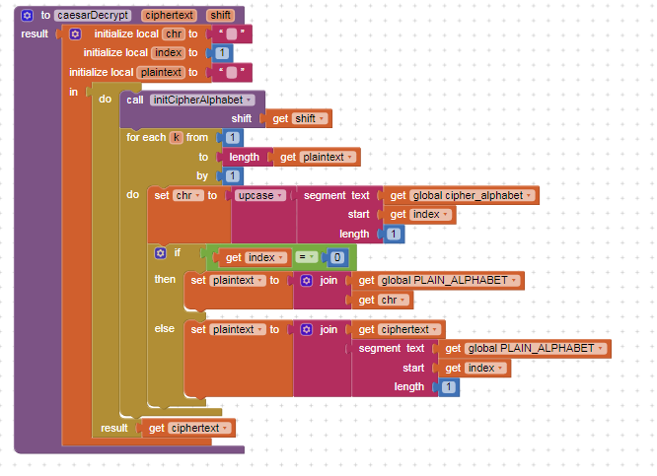

2. Explain the difference between a **function** and a **procedure**. Give an example of a **function**.

**Answer**

|  |
| --- |
| **A function gives a value or result and a procedure is used to reduce the complexity of the code. An example of a function is the return block with a parameter.** |

3. Explain the difference between **global** and **local** variables. Why are local variables easier to debug than global variables?

**Answer**

|  |
| --- |
| **Local variables are only accessible inside of a procedure or function. They can not be sent outside of this procedure or function without being upgraded to a global variable. They are easier to debug because they only exist within on set of blocks of code.** |